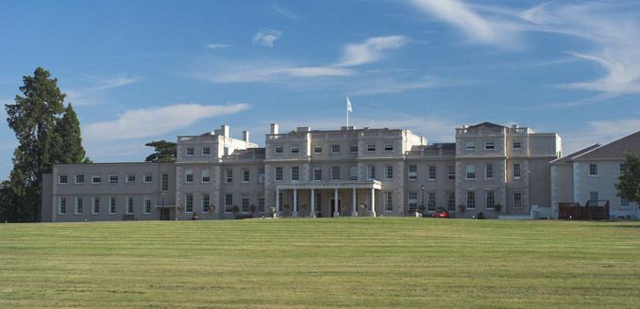
SCTE Informa Golf Day 2014



Wokefield Park GC
Thursday 2nd October

This year’s SCTE Informa Golf Day is to be held at the DeVere owned Wokefield Park Golf Club and Conference Centre near Reading in Berkshire.

Along with the golf day will be the chance for aspiring players to attend a golf academy which will be made up of three teaching sessions over a 5 hour period whilst the experienced golfers play a competitive round on the PGA standard 6,996 yard championship parkland course.
The day will start with coffee/tea and bacon rolls on arrival then 18 holes of golf followed by a 2 course dinner and prize presentation.
For the experienced golfers there will be prizes for longest drive, closest to the pin, best team score and lowest individual gross and net score. Both the novices and experienced golfers will have the chance to participate in a their own 9 hole putting competitions.
If you wish to participate please contact Amanda Ward or Frank Summerfield, contact details below.
For SCTE members the cost for the day will be £40.00
Non SCTE members £50.00
SCTE Patron Team £150.00 (4 players)

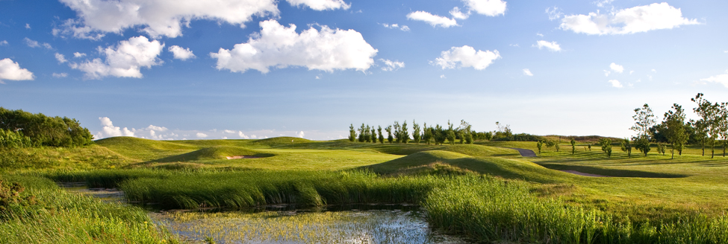

Bookings: Amanda Ward: amanda.ward@thescte.eu Tel: +44 (0) 1923 815 500
Information: Frank Summerfield: fsummerfield@cotswold-comms.co.uk Mob: +44 (0) 7714 755 498

